

Foundations of Programming

Assignment No.: 18
PROBLEM STATEMENT: Write a C program that accepts a string from the user and performs the following string operations: i) Calculate length of string ii) String reversal iii) Equality check of two strings iv) Check palindrome v) Check substring.

OBJECTIVE:

- To understand basic string operations in C.
- To learn how to manipulate strings using loops and functions.
- To perform comparison, reversal, and substring checking.
- To check whether a string is a palindrome.

THEORY:
In C programming, a string is a sequence of characters terminated by a null character ('\0'). Strings are commonly stored in character arrays. Various operations can be performed on strings such as calculating their length, reversing the characters, comparing two strings, checking whether a string is a palindrome, and finding a substring within another string. These operations can be implemented using loops and conditional statements or by using standard library functions from the string.h header file.
PLATFORM: Linux
ALGORITHM:
i) Algorithm to Calculate Length of String
- Start
- Input string str
- Set length = 0
- Repeat until str[length] = '\0'
- Increment length by 1
- Display length
- Stop

ii) Algorithm to Reverse a String
- Start
- Input string str
- Find length of string
- Set i = length - 1
- Repeat while i >= 0
- Print str[i]
- Decrement i
- Stop

iii) Algorithm to Check Equality of Two Strings
- Start
- Input string str1 and str2
- Compare both strings character by character
- If all characters are same
- Display "Strings are equal"
- Else display "Strings are not equal"
- Stop

iv) Algorithm to Check Palindrome
- Start
- Input string str
- Find length of string
- Compare first and last characters
- Continue comparison moving toward center
- If all characters match
- Display "Palindrome"
- Else display "Not Palindrome"
- Stop

v) Algorithm to Check Substring
- Start
- Input main string str
- Input substring sub
- Search sub inside str
- If found
- Display "Substring found"
- Else display "Substring not found"
- Stop

FLOWCHART:
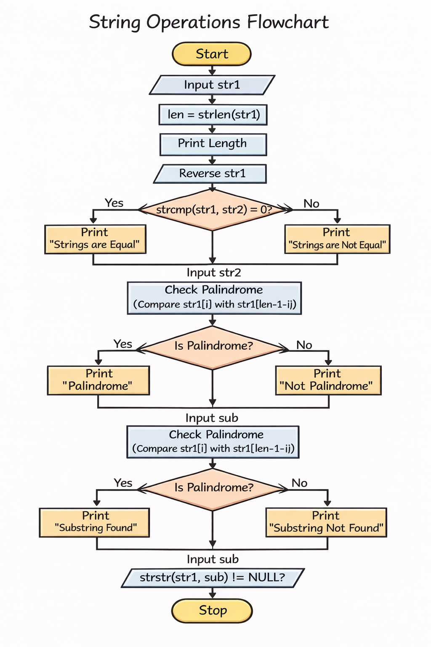

PROGRAM CODE:
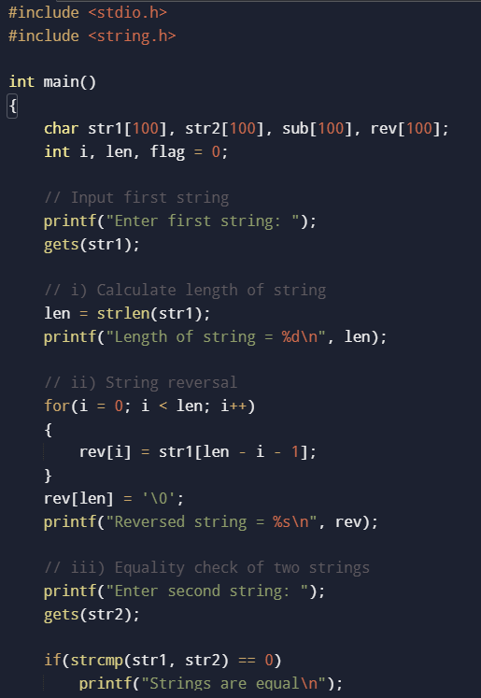

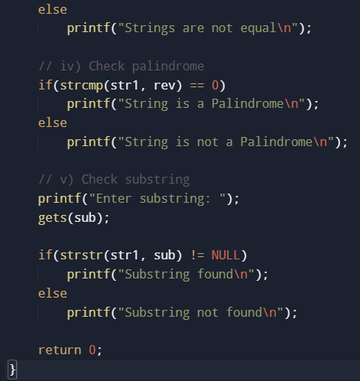
INPUT: A string and another string for comparison and substring checking.

OUTPUT: Displays string length, reversed string, equality result, palindrome result, and substring check result.

SAMPLE INPUT:

Enter a string: madam
Enter another string for equality check: mad
SAMPLE OUTPUT:
Length of string = 5
Reversed string = madam
The string is a Palindrome
Strings are not equal
Substring found in main string

CONCLUSION: Thus, the C program successfully performs different string operations such as length calculation, reversal, equality check, palindrome check, and substring detection.

FAQs:
- What is a string in C programming?
- Which header file is required for string functions?
- What function is used to find the length of a string?
- What is a palindrome string?
- Which function is used to check a substring in C?

